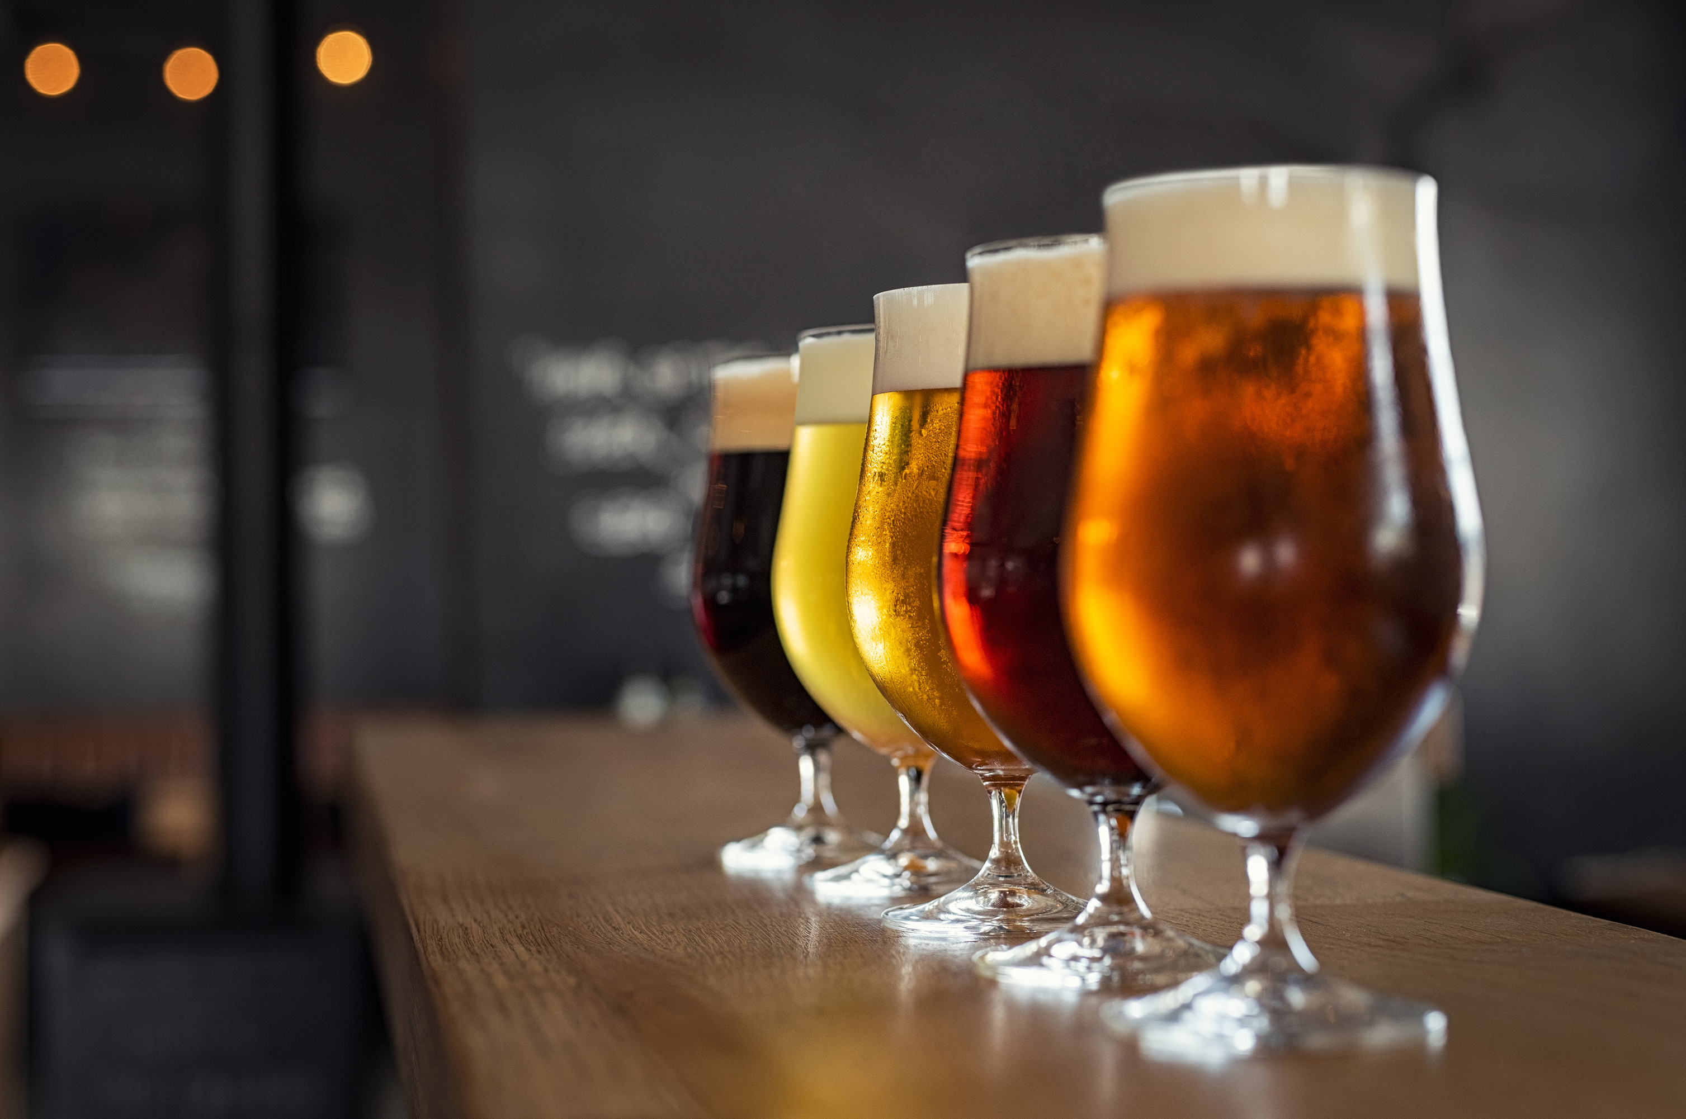  Where to find food and drinks outside Conference Hours!  * The Café is Open for breakfast and lunch (6:00AM – 1:30PM). Start your day on a bright note by enjoying the signature Wake Up DoubleTree Breakfast (bring voucher!)  * The Lobby Bar is Open (5PM – 1AM) * Domestic Beer = $5 each * Imported Beer = $6 each (Special Blue Knight Rates)  * In-room dining available (6AM–10PM)  * The Market offers snacks and quick meals for all times of the day and proudly serves Starbucks Coffee  Missouri liquor law sells beer, wine, and spirits at Gas Stations, Grocery Stores, and Liquor Stores Mon – Sun 6AM – 1:30AM | Where Are We:  Contact the Hotel:  DoubleTree by Hilton Hotel 16625 Swingley Ridge Rd Chesterfield MO 63017 844-201-8258  Contact MO III:  Doug Casteel (Pres.) 314-412-4449 Jeff Cook (VP) 314-540-7357  blueknightslemc@yahoo.com  www.blueknightsmo3.org Facebook – Blue Knights Missouri III  Local Attractions:  Butterfly House = 1 mile Top Golf = 3.6 miles 636/898-8044 St Louis Premium Outlet Mall = 7 mile St. Louis Zoo (free) = 15 miles Big St. Charles Harley Davidson = 17 miles Defiance, MO (wine country) = 18 miles Downtown St. Louis = 20 miles Main Street Old Town St. Charles = 20 miles Anheuser-Busch Brewery = 24 miles | 2023 fall mwrc hosted by: Missouri III  - September 14 – 17, 2023
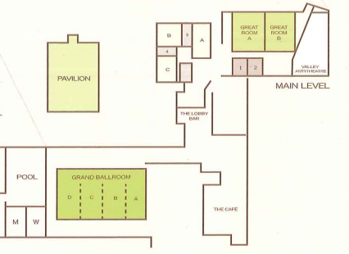  Most events will be in the Lower Level: Registration will be near the Lobby Bar D = Hospitality F = Hospitality H = Raffle Room I = Event Storage J = Sales and Sewing Friday Dinner will be outside in the back parking lot past Lobby Bar Saturday Meeting = Grand Ballroom A/B Saturday Dinner = Pavilion | What is the Itinerary:  Thursday – September 14, 2023  * Registration in Lobby (5PM – 7PM) RIDE -Fast Eddies/Bon Air 40 miles * Dinner – Your Option * Hospitality (6PM -12AM)  Friday – September 15, 2023  * Breakfast/Hotel Guest (7AM-10AM) * Registration in Lobby (9AM-10AM) RIDE - to Wine Country (10AM) * Hospitality (4PM – 7PM) * Dinner – Outside (7PM – 10PM) * Hospitality (10PM – 2AM)  Saturday – September 16, 2023  * Breakfast/Hotel Guest (7AM-10AM) * Business Meeting (9AM – 1030AM) Ride to Harley Davidson (1115AM) (Lunch Provided by dealership) RIDE to Wine Country Ride from HD with one stop planned (1PM) * Motor Safety/ Skills (Hotel lot 3PM) * Hospitality (3PM – 7PM) Doors Open for Dinner (6pm) * Dinner (7PM – 10PM) * Hospitality (1PM – 2AM) | Sunday – September 17, 2023  * Breakfast/Hotel Guests (6AM – 10AM)  * Departure – So Long, Fair Well, Until We Meet Again.  _______________________________________  Breakfast is complimentary for Hotel Guests with voucher provided by the Hotel at check in.  ***  FRIDAY Night Dinner on hotel back lot provided by Inner Fat Kid Diner Food Truck. Voucher provided by MO III.  